**Time Complexity**

**Problem 1 - Bilangan Prima**

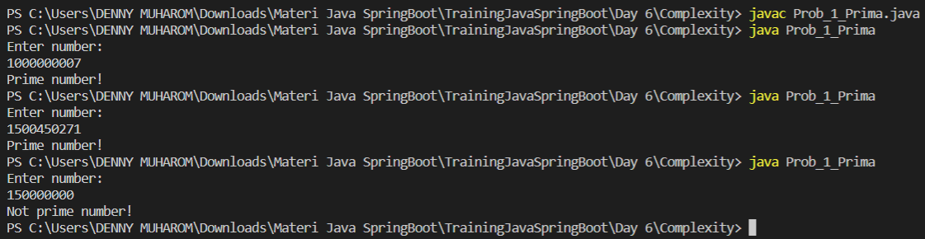

**Problem 2 - Fast Exponentiation**

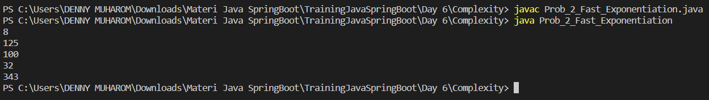

**Recursive and Teory Number**

**Problem 1 - Prima ke X (Tanpa Recursive)**

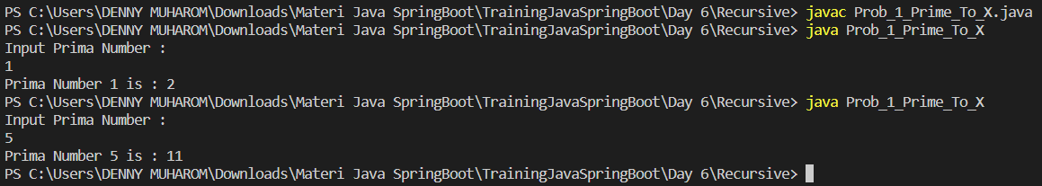

**Problem 2 - Fibonacci (Recursive)**

